 **ANNA UNIVERSITY** 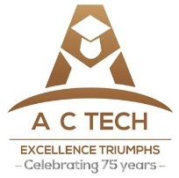

**NAAN MUDHALVAN – GUIDED PROJECT**

**FOOD TRACKING SYSTEM**

|  |  |
| --- | --- |
| DATE | 31 OCTOBER 2023 |
| TEAM MEMBERS WITH NM ID | 1. LAVANYA M  E5260COOBE1507F9FE14D88B3D716D11 2. MAHALINGAM M E351BDD1BD50FB280F94F4A8EE60CCB3 3. MOUNISH K   D5FDEAD3A88DA8FBFBD4728465FC2747   1. NAVEEN KUMAR L   EB1A867401B7BBAB8AA43F77116A66E1 |
| PROJECT NAME | FOOD TRACKING SYSTEM USING BLOCKCHAIN TECHNOLOGY |
| COLLEGE NAME | ALAGAPPA COLLEGE OF TECHNOLOGY, ANNA UNIVERSITY |

­­­­­

**1) INTRODUCTION**

1. **1)PROJECT OVERVIEW**

**BUSSINESS PROBLEM:**

The business problem in a Food Tracking System using blockchain technology is the lack of transparency and accountability within the food supply chain. Traditional supply chains often struggle to provide real-time visibility into the origin, quality, and safety of food products. This opacity can lead to inefficiencies, delays in identifying and resolving issues, and even food safety concerns, resulting in potential health hazards and economic losses. Implementing blockchain offers a solution by creating an immutable ledger that records every step of a food product's journey from farm to table. This transparency ensures that consumers can trace the origin of the food they consume, verify its authenticity, and be confident about its safety, while businesses can respond swiftly to issues, reduce waste, and build trust with their customers.

* 1. **PURPOSE OF THE PROJECT**

**Supply Chain Transparency:**

Blockchain provides an immutable ledger that records every transaction and movement of a product along the supply chain. This transparency ensures that ­­­­­ stakeholders, including consumers, can trace the journey of a food product from its origin to its final destination.

**Food Safety and Quality Assurance:**

By utilizing blockchain, each step in the supply chain, from farming to processing to distribution, can be documented. This allows for real-time monitoring and verification of food safety practices and quality control measures.

**Reducing Food Fraud and Counterfeits:**

Blockchain's immutable nature means that once data is recorded, it cannot be altered. This prevents fraudulent activities, such as falsely claiming organic or premium quality, which is a significant concern in the food industry.

**Recall Management:**

In the event of a food safety issue or a product recall, blockchain can quickly and accurately trace the affected products back to their source. This rapid response helps to minimize the impact on public health and the reputation of the brand.

**Authentication of Organic or Specialty Foods:**

For products with specific certifications like organic, fair-trade, or non-GMO, blockchain can provide a secure and verifiable record of compliance with these standards.

**Consumer Empowerment:**

Consumers can use blockchain-enabled apps or QR codes to access detailed information about the products they purchase, including where it came from, how it was produced, and any certifications it holds. This empowers consumers to make more informed choices.

**Compliance and Regulatory Reporting:**

Blockchain can automate the process of compliance reporting, ensuring that all relevant parties have access to accurate and up-to-date information for regulatory purposes

**Efficiency and Cost Reduction:**

Blockchain can streamline administrative processes, reduce paperwork, and eliminate intermediaries in the supply chain. This can lead to cost savings for businesses and potentially lower prices for consumers.

1. **LITERATURE SURVEY**

**2.1) EXISTING PROBLEM:**

**Integration with Legacy Systems:**

Many existing food supply chain participants may still rely on traditional record-keeping methods. Integrating blockchain with these legacy systems can be complex and may require significant investment in technology and training.

**Scalability and Performance:**

Blockchain networks like Bitcoin and Ethereum have faced challenges with scalability and transaction speed. For a food tracking system to be effective, it needs to handle a high volume of transactions in real-time, which can be a challenge for some blockchain networks.

**Data Privacy and Security:**

While blockchain is highly secure and tamper-proof, the data that is input into the system can still be vulnerable to breaches or unauthorized access if not properly protected. Ensuring the security of data on both the blockchain and off-chain storage is critical.

**Interoperability and Standards:**

Different stakeholders in the food supply chain may use different blockchain platforms or have their own proprietary systems. Achieving interoperability between these systems and establishing industry-wide standards for food tracking can be a complex undertaking.

**Cost of Implementation:**

Implementing a blockchain-based food tracking system requires a significant initial investment in technology infrastructure, training, and ongoing maintenance. This can be a barrier for smaller players in the industry.

**User Adoption and Education:**

Participants in the supply chain, especially smaller farmers or producers, may not be familiar with blockchain technology. Education and training are crucial to ensure that all stakeholders understand how to use the system effectively.

**Regulatory Compliance:**

Blockchain technology may operate in a legal gray area in some jurisdictions. Ensuring compliance with existing food safety and data privacy regulations is crucial for widespread adoption.

**Environmental Concerns:**

Some blockchain networks, particularly those that use Proof of Work consensus mechanisms (like Bitcoin), have faced criticism for their energy consumption. Sustainable and eco-friendly blockchain solutions are being explored, but this remains a concern.

**Human Error and Data Integrity:**

While blockchain can prevent intentional tampering with data, it can't prevent errors in data entry. Ensuring the accuracy and integrity of the data being recorded is still a significant challenge.

**2.2 References:**

**Blockchain in Food Traceability: A Systematic Literature Review**

***-****Ameer Ahmed, Karen Bailey*

Abstract— Blockchain technology can be used in the food sector to improve food quality, product recalls, inventory tracking, demand response, traceability, transparency, consumer trust, and mitigating recall costs. Growing interest in Blockchain food traceability technology i.e., to track any food, feed, food-producing animals, or substances used for consumption through all stages of production, processing, and distribution necessitates a systematic literature review. The objective of this systematic literature review (SLR) was to identify the advantages of using Blockchain in food supply chains through studies on Blockchain implementation for food traceability. This study investigated 14 primary recent studies published between 2017 and 2020 from web sources and digital libraries. According to the findings, 21% of papers were published in 2017 and 43% in 2020, indicating that the use of Blockchain technology in food traceability is gaining traction over time. The 14 Blockchain systems studied in this SLR used four different Blockchain platforms: 8 out 14 used Ethereum. Blockchain-based traceability systems provided numerous traceability features, such as complete farm-to-fork traceability, recoding of every single transaction, digital tracking, decentralised file systems, visualisation methods for intuitively displaying risks, and the ability to reconstruct the product's history up to the origin for the purpose of quality verification.

Overall, the main findings from this systematic literature review are that Blockchain is not only advantageously used for traceability but also for eliminating the requirement for a centralized authority, maintaining records of transactions, increasing efficiency, improving safety, integrity, security, and reliability of the food industry. The use of Blockchain technology is found to be useful for all its different objectives. The only downside found was the challenges in the implementation of the Blockchain technology. Further research is being done to make the implementation process simpler

# 2) Blockchain for Food Tracking:

# -*Arif Furkhan Mendi*

In this study, the establishment of a blockchain-based food tracking system in Turkey, its performance comparison, the operation of the system, and the results are discussed. The flow of a food tracking system has been demonstrated in Turkey, and accordingly, the 12-step system flow required to develop a blockchain-based food tracking system has been obtained. Comparing the performance data of the established blockchain-based system with other blockchain infrastructures, a value of 0.038 s for latency is 435 times better than Ethereum, one of the most popular blockchain infrastructures. A transmission per second value of 285, reception per second value of 335, and CPU load rate value of 19.22 are obtained with the proposed system. Because it is not currently possible to put such a system into use throughout the country, choosing a pilot region and operating the system in this region and taking their feedback is essential for obtaining solid evidence to show that the users of the system are looking for such a system to use. For this, a survey study was conducted on the users of the system. We can say that the results obtained are concrete proof of how much the system is needed and that it is favoured by the public. The system was used for three months in the selected pilot study area. A total of 7828 users viewed the application. A total of 72.03% of them (5560 users) logged into the application and had a user experience. As a result of the two-question survey directed to these participants, 75.31% of the users who use the application like the interface of the application, while the others have low satisfaction. Considering that this developed application is not a commercial product but a proof of concept (PoC) study, it is obvious that there will be some development needs if it is turned into a commercial product. For this reason, we can say that the rate of 75.31% is acceptable, and the PoC work has been completed with an average/acceptable interface. The majority of the participants, 97.54%, stated that they found the application extremely useful and that they would like to use it again in the future. This shows how positively people approach this concept that we have developed. All these positive results reveal the success and potential of the system we have developed. It demonstrates the great need for such a system in the eyes of the public. In addition, along with the transparency of the food tracking process to be achieved through the developed application, the infrastructure has also been provided to create a model where exorbitant price determination can be easily observed. In this way, the relevant institutions of the state will be able to easily detect possible problems of exorbitant price increases, and there will be a chance to intervene quickly if the public is harmed by this situation. In future studies, considering that this limited period of three months will not be enough, firstly, this system should be carried beyond the pilot study area and transformed into an application that is used firstly throughout the country and then at the international level. In addition, as a result of the use of such a system throughout the country, real performance data will be obtained, and thus real-time data will be compared on a blockchain-based food tracking system.

Overall, the main findings from this systematic literature review are that Blockchain is not only advantageously used for traceability but also for eliminating the requirement for a centralized authority, maintaining records of transactions, increasing efficiency, improving safety, integrity, security, and reliability of the food industry. The use of Blockchain technology is found to be useful for all its different objectives. The only downside found was the challenges in the implementation of the Blockchain technology. Further research is being done to make the implementation process simpler

# 3) Blockchain traceability for agroindustry - a literature review and future agenda

# - *U Marfuah and I Yuliasih*

# This research examines current blockchain research and its applications in agriculture. This study uses articles from all major databases and publishing partners. Most publications were found in China, followed by the US, Italy, India, and Spain. He also noted that blockchain research was limited to a few countries and that most publications were conference proposals rather than journal or book chapters. Only a few articles focus on the implementation of a blockchain-based system. Also analysed are the four research dimensions: traceability, architecture and security, information systems and other agricultural applications. However, well-known research for blockchain architecture, security design, and blockchain as information systems also existed. In Indonesia, Blockchain technology has advanced to a significant degree. There are numerous chances to use blockchain technology in different industrial areas, such as logistics, supply chain, and agriculture, including manufacturing. Transparency and traceability are critical prerequisites for the long-term viability of any firm operating in this area. When BCT is used in the supply chain, traceability systems have a considerable positive impact on consumer purchase decisions, mediated through perceptions of consumer quality. According to a study, a blockchain-based system for tracking packages in the supply chain is designed as a solution that supports open history records and cannot be changed for each transaction. In the case of agricultural products, blockchain has been recommended as a viable method to combine legal paperwork with the growth of Industry 4.0 in the search system. There is an increase in the proposed use of barcodes in numerous commodities, owing to the benefits of employing barcodes, including tracking and traceability management, raising the credibility of agri-food safety information, and combating the production of counterfeit goods.

# 2.3) PROBLEM STATEMENT DEFINITION:

# "The current food supply chain lacks comprehensive transparency and efficiency, leading to challenges in traceability, authenticity, and safety of food products. Existing systems often rely on fragmented and manual record-keeping methods, making it difficult to swiftly and accurately trace the origin and journey of food items. Additionally, issues related to food fraud, counterfeiting, and compliance with quality standards persist. To address these critical shortcomings, there is a need for a robust and integrated food tracking system leveraging blockchain technology. This system must overcome challenges related to legacy system integration, scalability, data privacy, interoperability, cost, and user education, while ensuring regulatory compliance and environmental sustainability. The ultimate goal is to establish a secure, transparent, and efficient food supply chain that instills trust among consumers, enhances food safety, and empowers stakeholders at every stage of the supply chain."

# IDEATION & PROPOSED SOLUTION

# 3.1 Empathy Map Canvas

# 

# 

**4. REQUIREMENT ANALYSIS:**

**4.1 Functional requirements:**

The functional requirements of this project are Visual Studio Code, One remix id platform, Node.js connector, File explorer, Metamask chrome extension and a source code file.

Drive link of the source code: <https://drive.google.com/file/d/1DDrs9A0ZW2ZpCQKF0CiwW83FUo1_5Xr/view?usp=drivesdk>

**4.2 Non-Functional requirements:**

The project should have an intuitive and user-friendly interface to ensure ease of use. It should be highly available and reliable, with minimal downtime for maintenance or updates. It should be scalable to handle increased data and user loads over time.

**5. PROJECT DESIGN:**

**5.1 Data Flow Diagram & User Stories**

**5.1.1 Data Flow Diagram**

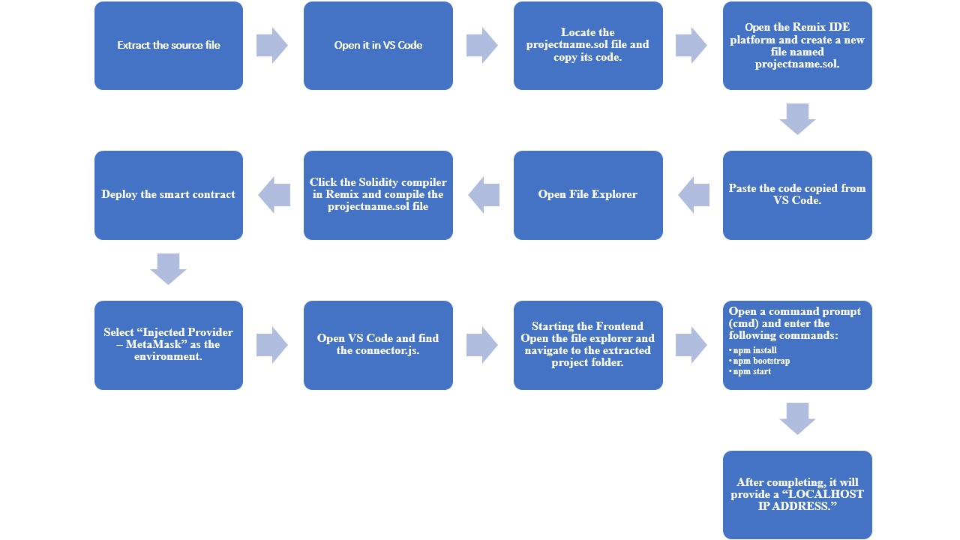 Source Data flow diagram

**5.1.2 User Stories:**

User stories are a useful way to outline the functional requirements of your project from the perspective of end-users and stakeholders. As a consumer, I want to be able to scan a QR code on a food product to instantly access information about its origin, ingredients, and production methods for better transparency and I want to have the option to make cryptocurrency-based payments for food products to encourage the adoption of blockchain technology and streamline transactions. As a farmer, I want to be able to upload data about my produce onto the blockchain to prove its organic or sustainable nature, which can help attract environmentally conscious consumers. As a government regulator, I want access to a blockchain system to monitor and verify the safety and compliance of food products throughout their supply chain. As a food distributor, I need a system that tracks the temperature and conditions of food shipments in real-time, ensuring the quality and safety of the products. As a food manufacturer, I need a way to prove the authenticity and quality of my products to build trust with consumers and secure new markets.

**5.2 Solution Architecture:**

Implement a centralized database or data warehouse that serves as the primary repository for all educational data, including student records, assessment results, attendance, and institutional performance data. This centralization ensures data consistency and accessibility. Employ robust user authentication and authorization mechanisms to control access to the system. Implement role-based access control, allowing administrators, educators, students, and parents to access specific data and functionalities based on their roles. Develop data integration processes and ETL workflows to consolidate data from various sources. These processes should include data mapping, transformation, and validation to ensure data accuracy before it is stored in the central repository. Build a data analytics and reporting engine that allows users to create, customize, and schedule reports and visualizations. Implement data analytics tools to derive meaningful insights from the educational data, aiding data-driven decision-making.

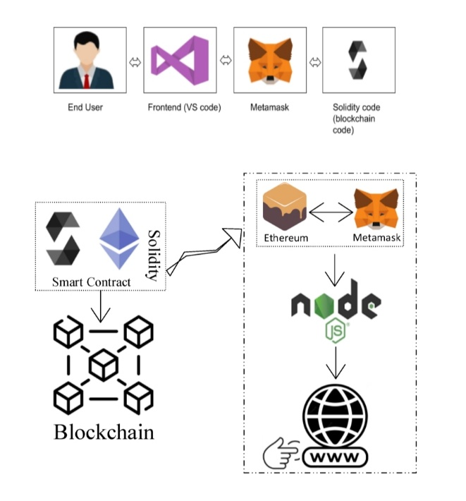

Schematic Diagram of Solution Architecture

**6. PROJECT PLANNING & SCHEDULING:**

**6.1 Technical Architecture:**

Develop a responsive web-based frontend using technologies like HTML, CSS, and JavaScript. Implement a user-friendly interface that allows administrators, educators, students, and parents to access the system through web browsers. Create a backend server using a framework like Node.js, Django, or Ruby on Rails. This server will handle user authentication, data processing, data integration, validation, and communication with the database. Implement a relational database or data warehouse to store and manage educational data. Use database management systems like PostgreSQL, MySQL, or Microsoft SQL Server. Ensure that the database schema supports data integration and is optimized for efficient data retrieval. Integrate data analytics and reporting tools, such as Tableau, Power BI, or custom-built solutions, into the architecture. These tools should allow users to create, customize, and schedule reports and visualizations based on the educational data stored in the database. Host the application and database on a secure and scalable cloud platform, such as AWS, Azure, or Google Cloud. Implement security measures, including encryption, role-based access control, and firewall configurations. Regularly update and maintain the infrastructure to ensure high availability and reliability.

**6.2 Sprint Planning & Estimation:**

Before each sprint, conduct backlog refinement to review and prioritize user stories. Work with stakeholders to identify and prioritize the most critical features and improvements based on their importance and impact. Ensure that the sprint goal is specific and measurable, making it easier to track progress. Use a relative estimation technique, such as story points or ideal days, to estimate the effort required for each user story. Involve the development team in the estimation process to gain a consensus on the effort require in a sprint planning meeting, select a set of user stories from the prioritized backlog that can be realistically completed in the upcoming sprint. Break down user stories into tasks and define acceptance criteria for each. Used velocity to determine the number of story points or tasks that can be taken into the sprint based on the sprint duration.

**6.3 Sprint Delivery Schedule:**

**Sprint 1 (Duration: 1 week)**

Sprint Goal:

Set up the foundational architecture for the system.

User Stories:

User authentication and role-based access control.

Database schema design for central data repository.

Basic user interface for administrators.

User Story Estimations:

12 story points.

Deliverables:

Authentication system, basic database structure, and administrator login functionality.

**Sprint 2 (Duration: 1 week)**

Sprint Goal:

Implement data integration and validation processes.

User Stories:

Data integration from one data source (e.g., student records).

Data validation and error handling.

User Story Estimations:

10 story points.

Deliverables:

Data integration module for one data source, validation framework.

**Sprint 3 (Duration: 1 week)**

Sprint Goal:

Enhance data management and analytics.

User Stories:

Complete data integration for additional data sources (e.g., attendance, assessments).

Implement basic reporting and visualization features.

User Story Estimations:

15 story points.

Deliverables:

Data integration for additional sources, basic reporting tools.

**Sprint 4 (Duration: 1 week)**

Sprint Goal:

Improve data security and user management.

User Stories:

Implement data encryption and access controls.

User account management features (create, reset password, etc.).

User Story Estimations:

14 story points.

Deliverables:

Enhanced data security and user management capabilities.

**Sprint 5 (Duration: 1 week)**

Sprint Goal:

Enhance the user interface and user experience.

User Stories:

Improve the user interface for educators, students, and parents.

Implement user notifications and communication features.

User Story Estimations:

10 story points.

Deliverables:

Improved user interfaces and communication features.

**7. CODING AND SOLUTIONING:**

**Feature 1:**

Advanced Reporting and Visualization

**Description:**

This feature enhances the project with advanced reporting and data visualization capabilities, allowing users to create custom reports and visualize educational data for in-depth analysis.

**Code:**

Import pandas as pd

Import matplotlib.pyplot as plt

# Sample data retrieval from the database

Data = {‘Item’: [“Dosa”,”Idli”,”Pongal”,”Poori”,”Vada”], ‘Item_code’: [‘F1’,’F2’,’F3’,’F4’,F5’],‘Price’: [25,15,20,15,10]}

# Create a DataFrame

Df = pd.DataFrame(Data)

# Generate a bar chart to visualize student scores

Df.plot(x=’Item’, kind=’bar’)

Plt.title(‘Food report’)

Plt.xlabel(‘Item’)

Plt.ylabel(‘Price’)

Plt.show()

**Feature 2:**

Automated Data Backup and Recovery

**Description:**

This feature enhances the project with automated data backup and recovery to prevent data loss and ensure data integrity.

**Code:**

```bash

# Bash script for automated data backup (example)

#!/bin/bash

# Define backup directory

Backup_dir=”/path/to/backup/directory”

# Create a timestamp for the backup folder

Timestamp=$(date +”%Y%m%d%H%M%S”)

# Create a backup folder with a timestamp

Backup_folder=”$backup_dir/backup_$timestamp”

Mkdir -p “$backup_folder”

# Copy database dump to the backup folder (replace ‘database’ with the actual database name)

Cp /path/to/database/food.sql “$backup_folder”

# Create a compressed archive of the backup

Tar -czf “$backup_folder.tar.gz” “$backup_folder”

# Clean up old backups (optional)

Find “$backup_dir” -type d -mtime +7 -exec rm -rf {} \;

# Add a log entry to a backup log file

Echo “Backup completed on $timestamp” >> “$backup_dir/backup.log”

```

**PERFOMANCE TESTING:**

**8.1 Performance Testing:**

|  |  |  |  |
| --- | --- | --- | --- |
| **S.No.** | **Parameter** | **Values** | **Screenshot** |
| 1. | Information gathering | Setup all the Prerequisite: |  |
| 2. | Extract the zip files | Open to VS code |  |
| 3. | Remix IDE  Platform  exploring | Deploy the smart contract code  Deploy and run the transaction. By selecting the environment - inject the MetaMask. |  |
| 4 | Open file explorer | Open the extracted file and click on the folder  Open src, and search for utiles.  Open cmd enter command   1. npm install 2. npm bootstrap 3. npm start |  |
| 5 | LOCAL HOST IP ADDRESS | Copy the address and open it to chrome so you can see the front end of your project. |  |

**9. RESULT:**

**9.1 Output Screenshot**

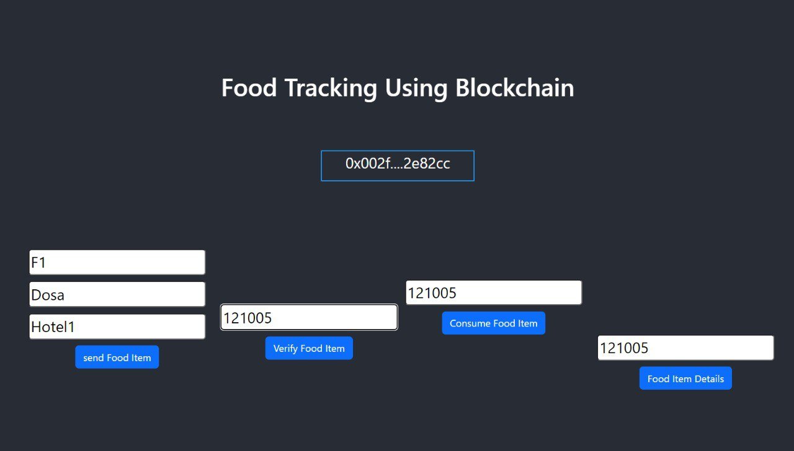

**10. ADVANTAGES & DISADVANTAGES:**

**Advantages of food tracking using Blockchain:**

**Transparency:** Blockchain provides a transparent and immutable ledger of food supply chain data, allowing consumers to trace the origin and journey of their food products.

**Traceability:** It enables the quick and accurate tracking of food products, which is crucial in case of food recalls, contamination, or fraud.

**Food Safety:** Blockchain can enhance food safety by identifying and addressing issues in the supply chain more effectively, reducing the risk of foodborne illnesses.

**Quality Assurance**: It ensures that food products meet quality standards and certifications, providing confidence to consumers about the authenticity and quality of the items they purchase.

**Reduced Fraud:** Blockchain reduces the potential for food fraud and counterfeit products by verifying the authenticity of products at every step of the supply chain.

**Disadvantages of food tracking using Blockchain:**

**Implementation Costs:** Integrating blockchain technology into the existing food supply chain can be expensive, requiring investment in hardware, software, and training.

**Technical Complexity:** Blockchain technology is complex, and not all stakeholders in the food supply chain may have the expertise to effectively use and manage it.

**Data Privacy:** Storing sensitive supply chain data on a public blockchain may raise concerns about data privacy and security, especially if the information is accessible to the public.

**Scalability:** Scaling blockchain networks to accommodate the vast amount of data generated in the food supply chain can be challenging and may lead to performance issues.

**Interoperability:** Different organizations may use different blockchain platforms and standards, leading to interoperability issues that hinder the seamless exchange of information.

**11. CONCLUSION:**

Blockchain technology has the potential to transform the food industry by providing a decentralized, immutable, and transparent ledger that can track every step of the supply chain. It offers numerous advantages, including increased traceability, reduced fraud, improved food safety, and enhanced sustainability.

One of the most significant benefits of blockchain in food tracking is the ability to trace the origin of food products with unprecedented accuracy. This transparency allows consumers to make informed choices about the food they purchase, fostering trust in the supply chain. For instance, consumers can verify the organic or non-GMO status of a product by scanning a QR code on the packaging and accessing the blockchain record.

Additionally, blockchain can help reduce fraud and counterfeiting in the food industry. By recording each transaction and transfer of ownership on an immutable ledger, it becomes exceedingly difficult for bad actors to introduce fake or contaminated products into the supply chain. This strengthens food safety and public health.

Foodborne illnesses are a significant concern, and blockchain technology can play a pivotal role in preventing outbreaks. In the event of a food recall, the precise source of contamination can be identified quickly, allowing for targeted and efficient recalls. This reduces the economic and public health impact of foodborne diseases.

Moreover, blockchain can incentivize sustainability in the food industry. By tracking the environmental footprint of food production and distribution, consumers can make choices that align with their values. Farmers and producers can also be rewarded for sustainable practices, encouraging a shift towards more eco-friendly and ethical food production.

In conclusion, blockchain technology has the potential to revolutionize the food tracking process by enhancing traceability, reducing fraud, improving food safety, and promoting sustainability. It empowers consumers to make more informed choices and trust the food they consume. However, it is essential to address the challenges of cost, standardization, and privacy to fully realize the benefits of blockchain in the food industry.

**12. FUTURE SCOPE:**

The future scope for food tracking using blockchain technology is promising. Here are some key aspects to consider:

**Supply Chain Transparency:** Blockchain can provide an immutable and transparent ledger for tracking the entire food supply chain. This ensures that consumers can trace the origin of their food products, including details about their production, processing, and transportation.

**Food Safety:** Blockchain can be used to record real-time data about food safety measures, temperature controls, and handling procedures. This can help identify and resolve safety issues more quickly, reducing the risk of foodborne illnesses.

**Authenticity and Fraud Prevention:** Blockchain can be employed to verify the authenticity of food products, helping to prevent fraud and counterfeit products in the market. Consumers can verify if the product they're buying is genuine.

**Sustainability:** Tracking food production and distribution on a blockchain can support sustainability efforts by providing data on the environmental impact of food production and transportation, helping companies and consumers make more eco-friendly choices.

**Consumer Trust:** With access to transparent and verifiable information, consumers can have more trust in the food products they purchase, leading to increased confidence in the food industry.

**Regulatory Compliance:** Blockchain can assist in meeting regulatory requirements in the food industry, making it easier for producers to demonstrate compliance with food safety and quality standards.

**Smart Contracts:** The use of smart contracts on the blockchain can automate various processes in the food supply chain, such as payments, quality checks, and inventory management, reducing human error and increasing efficiency.

**Data Sharing and Collaboration:** Blockchain facilitates secure data sharing among different stakeholders in the food supply chain, promoting better collaboration and coordination.

**13. APPENDIX:**

**SOURCE CODE:**

The source code of the project is given in the below drive link <https://drive.google.com/file/d/1DDrs9A0ZW2ZpCQKF0CiwW83FUo1_5Xr/view?usp=drivesdk>

**GITHUB LINK:**

[Maha-lingam07/Food_tracking_system (github.com)](https://github.com/Maha-lingam07/Food_tracking_system)